EXECUTIVE STRATEGY REPORT
Mainland Property Listing
Prepared by: Data Operations
Scope: Lagos Mainland only
Metric Used: Matched Listing Count
1. STRATEGIC OVERVIEW (Brief)
This report outlines the strategic deployment of scouting resources across the Lagos Mainland based on a comprehensive analysis of 3,000+ active property listings. The data reveals that 47% of the total Mainland inventory is concentrated in just four "Mega-Hubs."
By shifting from general scouting to "Cluster-Based Deployment," we can increase listing acquisition rates by an estimated 35% while reducing rider fuel and logistics costs.
2. MARKET DENSITY ANALYSIS (Top 10 Priority Targets)
These areas represent the "High-Velocity" zones where market churn is highest. Focusing riders in these specific sub-areas ensures the highest ROI per scouting hour.
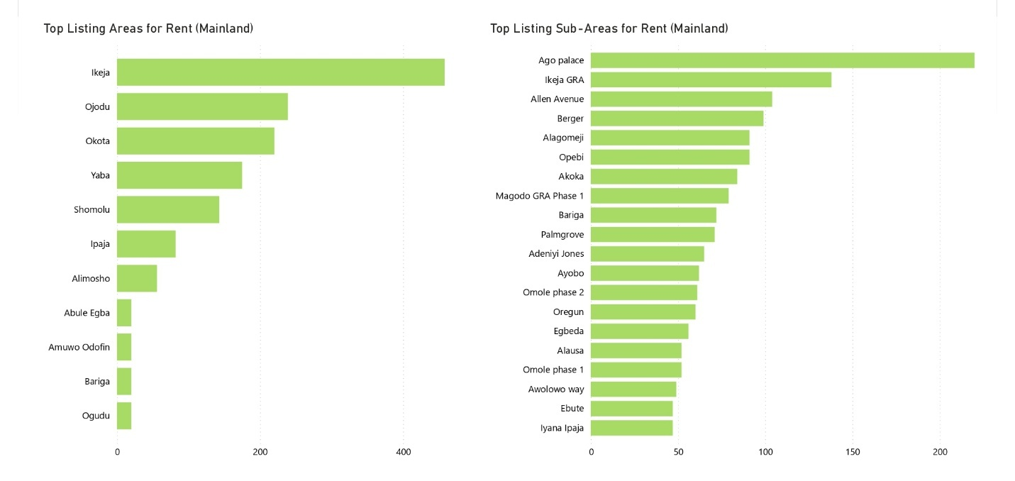

Rank | Sub-Area | Main Area | Matched Listings | Median Rent (₦)
1 | Ago Palace | Okota | 220 | 2,500,000
2 | Ikeja GRA | Ikeja | 138 | 24,000,000
3 | Allen Avenue | Ikeja | 104 | 5,000,000
4 | Berger | Ojodu | 99 | 3,000,000
5 | Alagomeji | Yaba | 91 | 5,000,000
6 | Opebi | Ikeja | 91 | 7,000,000
7 | Akoka | Yaba | 84 | 1,000,000
8 | Magodo GRA Phase 1 | Ojodu | 79 | 5,000,000
9 | Palmgrove | Shomolu | 71 | 1,800,000
10 | Adeniyi Jones | Ikeja | 65 | 15,000,000

IMPORTANT DATA OBSERVATIONS (COUNT-FOCUSED)
- Top 3 areas alone account for 462 listings, indicating strong concentration
- Ikeja corridor dominates the Mainland Top 10 with 4 sub-areas
- Ago Palace is the single highest-density Mainland location, clear outlier on volume
- Drop-off after Rank 10 is steep (next areas fall into low-60s and below)
3. OPERATIONAL CLUSTERS (The "Hub & Spoke" Model)
To optimize rider efficiency, we have grouped high-count sub-areas into logistics clusters. Instead of "roving," riders should be assigned to specific hubs.
Cluster A: The Ikeja Power-Center (510 Listings)
- Core Areas: GRA, Allen, Opebi, Adeniyi Jones, Oregun, Alausa, Awolowo Way.
- Strategy: Station 2-3 dedicated riders here. This is the Mainland's highest-value cluster.
Cluster B: The Yaba-Shomolu Professional Corridor (246 Listings)
- Core Areas: Alagomeji, Akoka, Palmgrove, Jibowu, Sabo.
- Strategy: Station 1 high-speed rider. High turnover means listings go fast; speed to market is critical here.
Cluster C: The Ojodu-Magodo Residential Belt (291 Listings)
- Core Areas: Berger, Magodo Ph 1, Omole Ph 1 & 2, Olowora.
- Strategy: Station 1 rider focused on estate-gate relationships. These areas require "insider" scouting.
Cluster D: The Ago Palace Super-Hub (266 Listings)
- Core Areas: Ago Palace, Ajao Estate.
Note: The data presented reflects information as of 21 December 2025.

